1. Sign in to your Okta org as an admin.
2. In the Admin Console, go to **Settings** >**Downloads**.
3. Go to the Okta Access Gateway section.
4. Select the OVA image for VMware Workstation specific download When prompted, save the file to an appropriate location.
5. Open VMware Workstation Player.
6. Select **Open a Virtual Machine**.

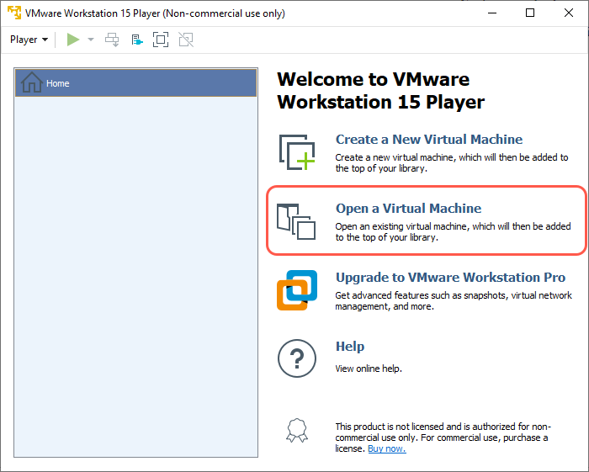

1. Select the **Okta-Access Gateway** OVA file, and click **Open**.

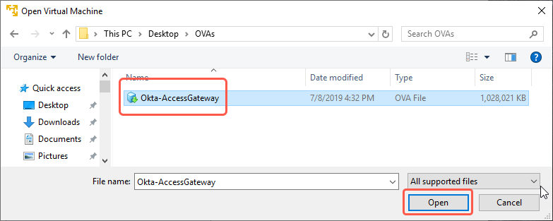

1. Enter a name for the virtual machine, and click **Import**.

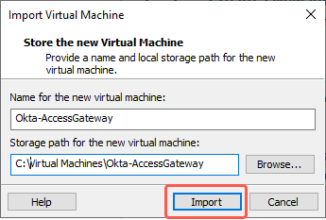

1. VMware starts importing the OVA file.

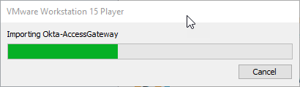

1. After the VM has imported, click **Play virtual machine** to start the VM and open a terminal.

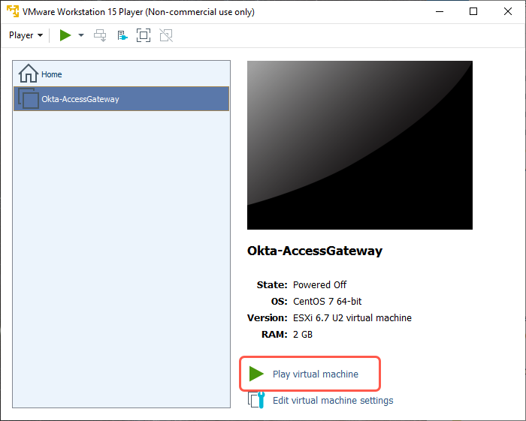

1. Sign in to the Access Gateway Management console.

Username: oag-mgmt

Password: [<default-password>](https://help.okta.com/en/prod/Content/Topics/Access-Gateway/learn-about-default-credentials.htm)

1. Enter 1 to select the Network menu.
2. Enter s to display the current running system configuration.  
   The **eth0** section of the page shows the IP address of the server.  
   Make note of this IP address.

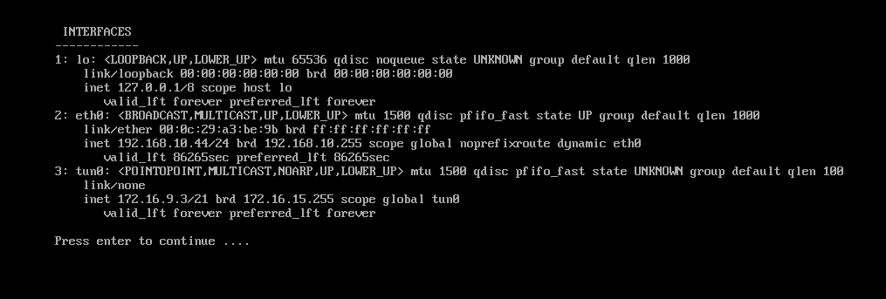

1. For Windows, you can find the host file in c:\windows\system32\drivers\etc\hosts. Within this file add the entry of the ip address copies in the previous step “ip of instance  admin”
2. Save the file

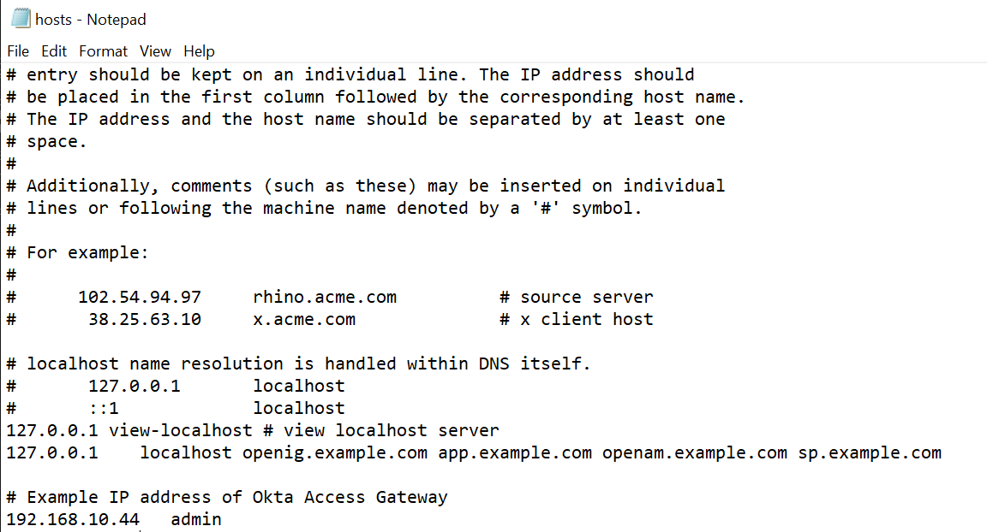

1. To initialize the Access Gateway Console: open a browser and navigate to <https://admin/>.
2. Note: If you get the below error, certain steps need to be performed

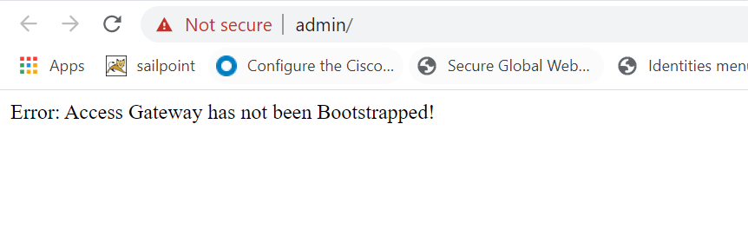

* 1. Go back to the Access Management console in your VM
  2. At the command line main menu:
* Enter 5 - System.

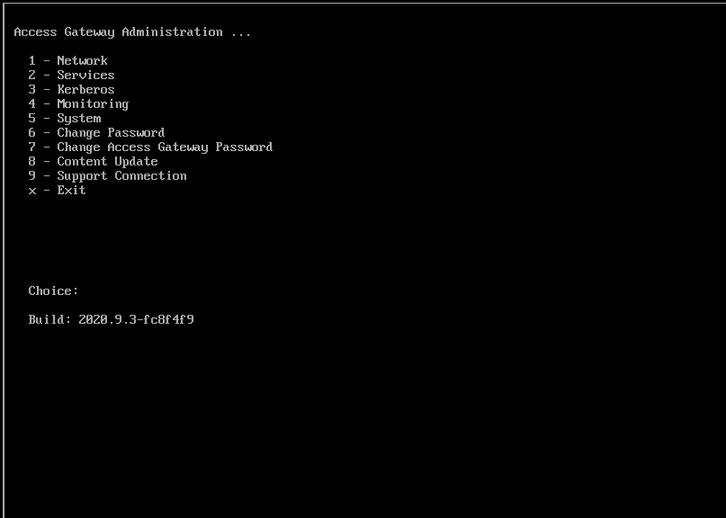

* Enter 7 - Reset.

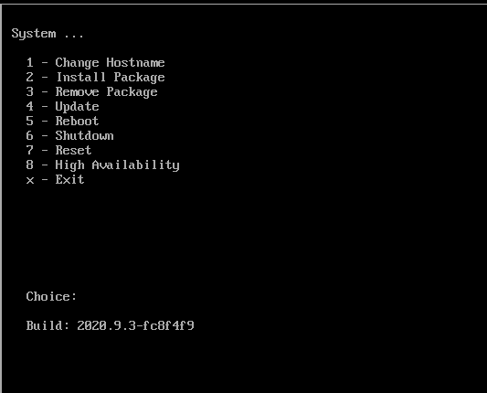

* Enter Y to clear the configuration.
* Enter Y to initialize the system.

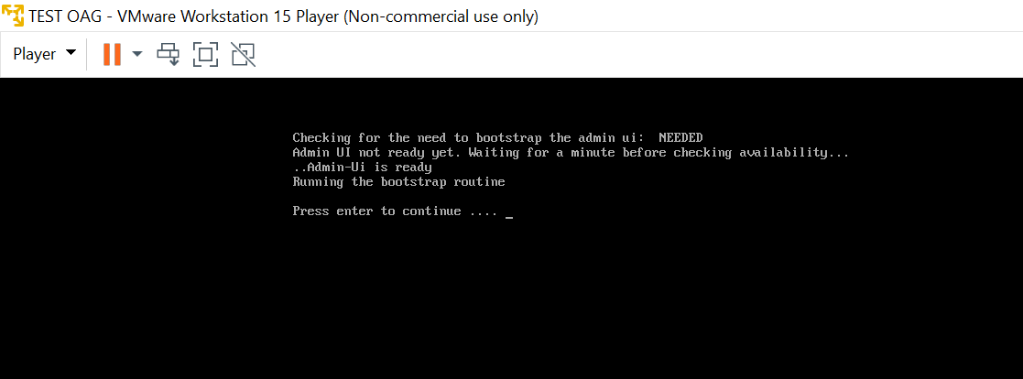

* 1. After the system is initialized successfully, press any key to return to the menu.

**Verify Configuration**

* Enter x to return to the main menu.
* Enter 1 - Network.
* Enter 3 - Test network configuration.  
  Okta Access Gateway attempts to contact www.okta.com and report any errors.
* Enter 9 - Connectivity test.  
  Enter www.okta.com as host and 443 as port.
* Confirm that the connection was successful.

1. Open your browser again and navigate to <https://admin/>.
2. Sign in to the Access Gateway Admin UI console with the following credentials:

Username: admin

Password: [<default-password>](https://help.okta.com/en/prod/Content/Topics/Access-Gateway/learn-about-default-credentials.htm)

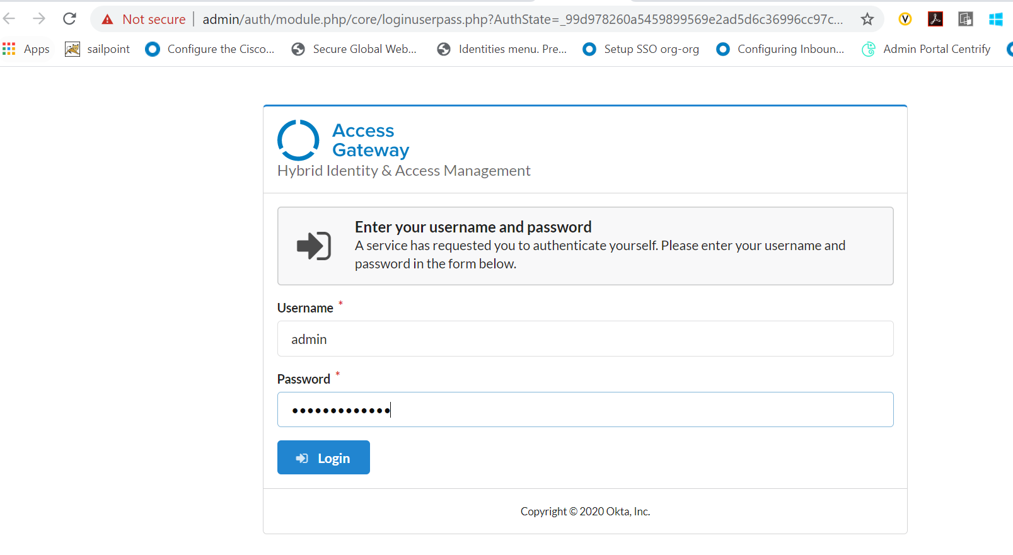

1. Note down the **cookie domain** and **hostname** for the Access Gateway instance, and click **Next**.

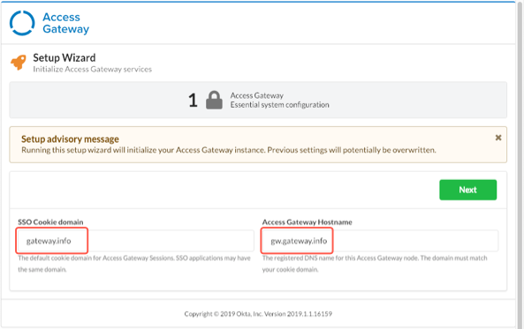

1. Click **Done**.
2. Add the domains to the host file.

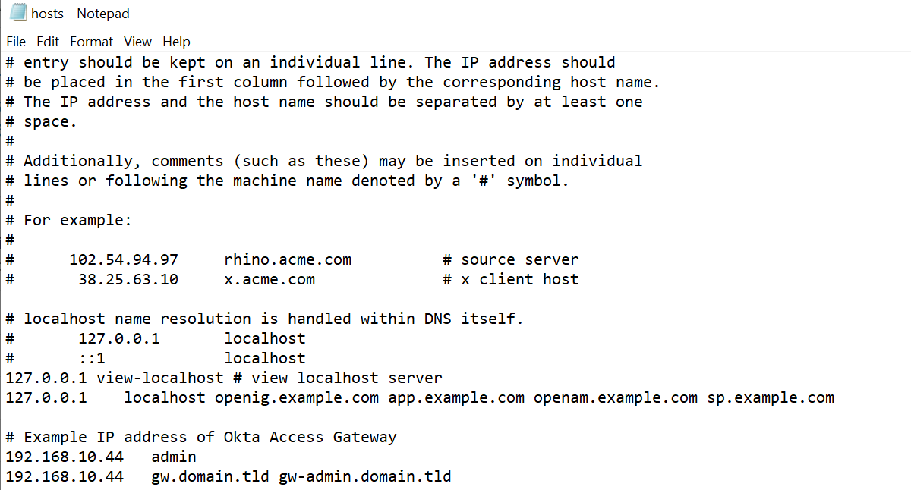

1. Return to the Access Gateway browser and sign in again using the new admin domain.
2. After signing in, you are directed to the Access Gateway Admin Topology page.

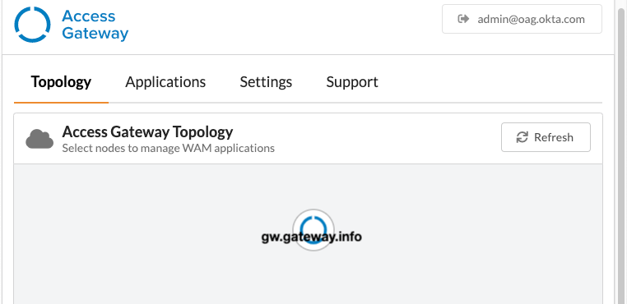

1. Create a service account in Okta and using that service account create an API token in Okta. Copy the Token Value in a safe place.
2. Navigate to the Access Gateway Admin UI console in the browser and sign in as an administrator.
3. Select the Settings tab.
4. Click the Identity Providers pane.
5. Click + and select OKTA.
6. In the Name field, enter the name of an app.
7. In the Okta Org URL and Okta API Token fields, enter the values generated earlier
8. Click Not Validated.  
   Once the Okta API Token is validated successfully, the Not Validated button changes to Validated

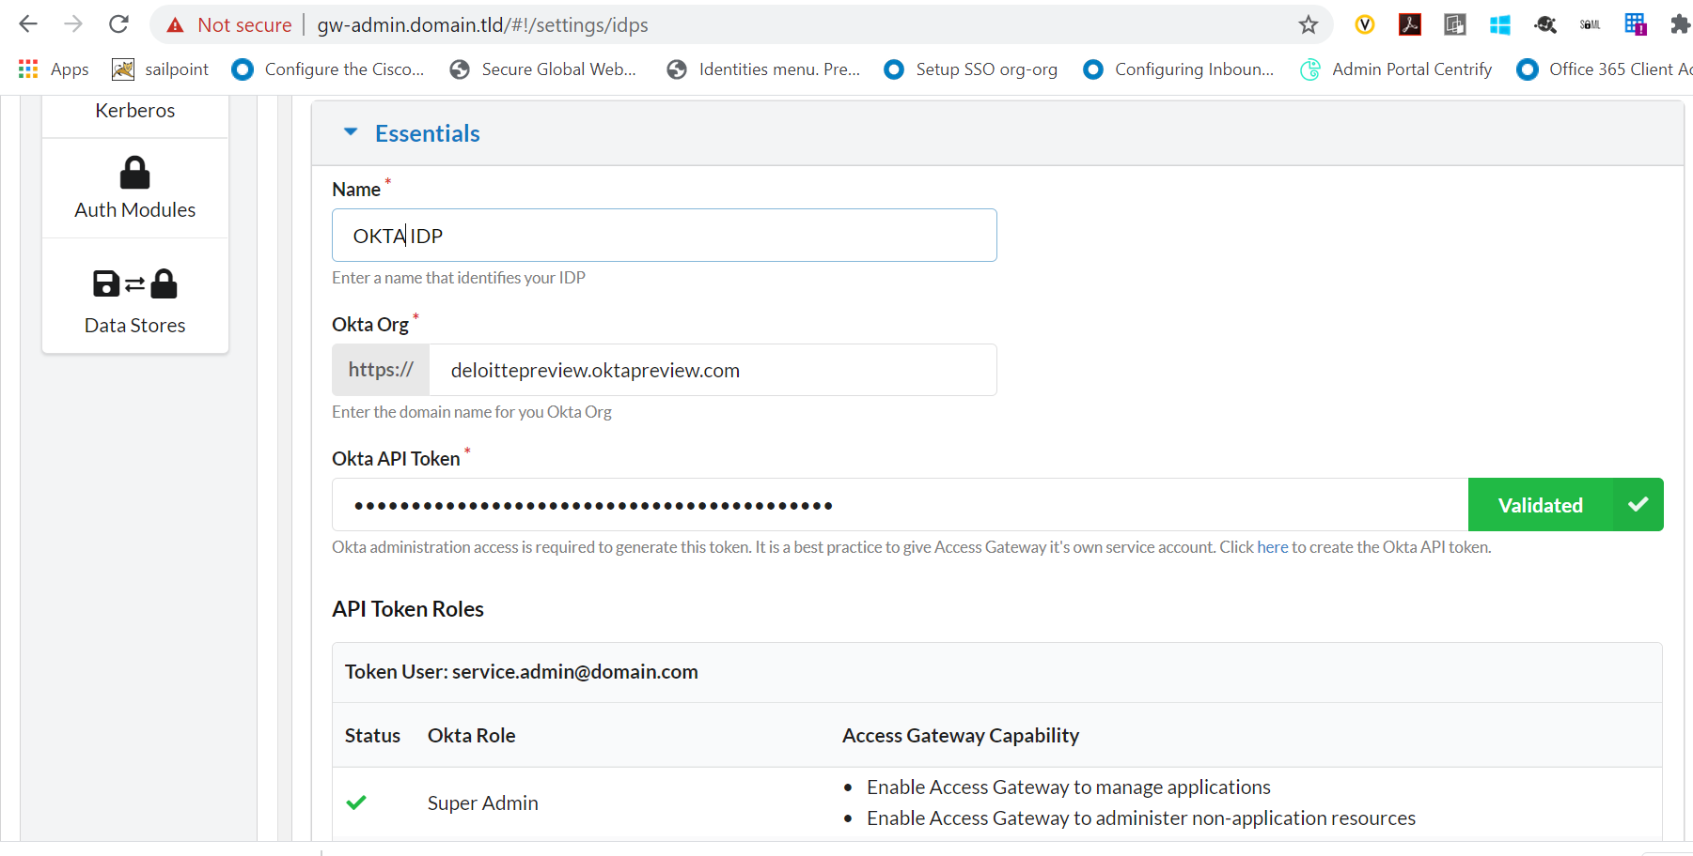

1. Click Okay. The Settings tab displays your Okta IDP status.
2. Verify that it displays the status as Valid.

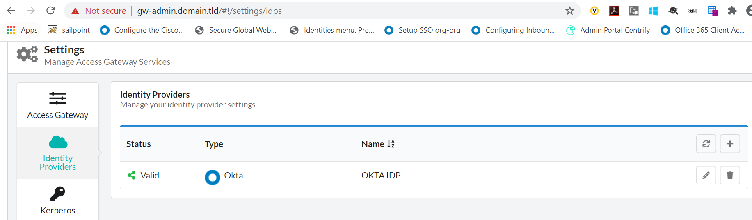

1. Navigate to the Topology tab to test the IDP’s connection.
2. Click the Okta IDP icon to be redirected to your Okta tenant.

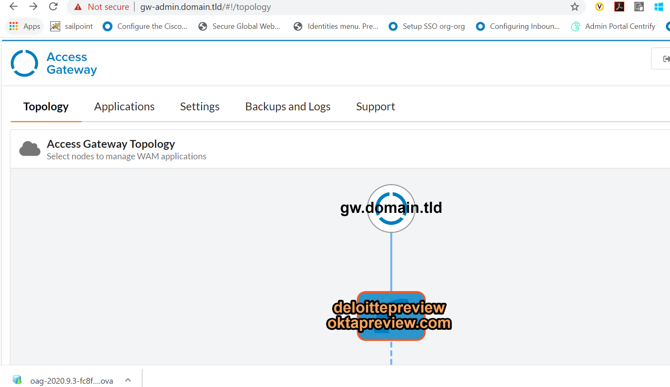

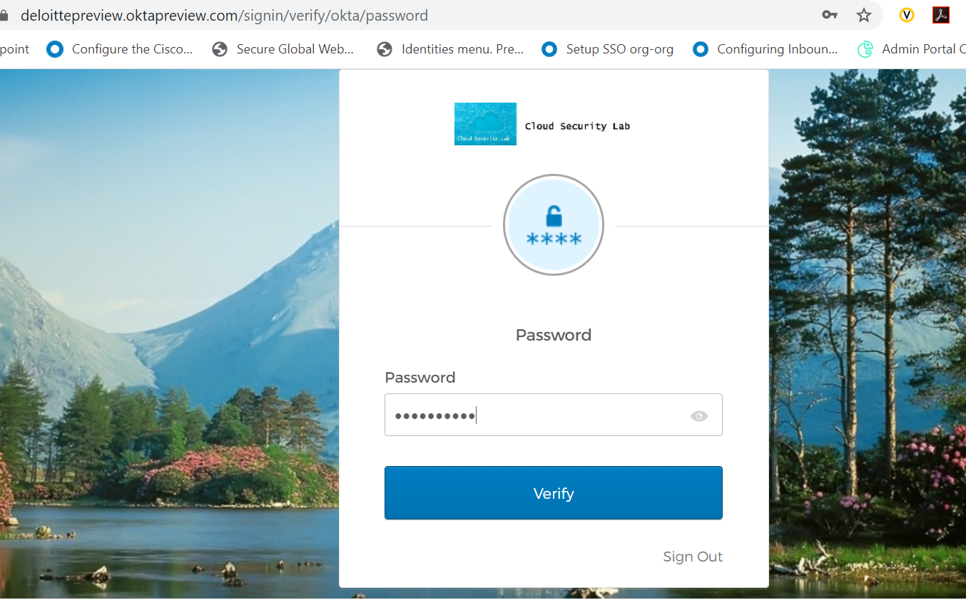

1. In your browser, sign in to your Okta org as administrator.
2. In the Admin Console, go to **Directory** >**Groups**.
3. Click **Add Group.**
4. In the **Add Group** dialog box, enter the name of the group and add a description.

Click **Add Group**.

1. Click the name of the newly added group.
2. Click **Manage People** and add all users who should be able to administer Okta Access Gateway.
3. Click **Save**.
4. In the Okta Access Gateway browser window.
5. Select the **Application** tab.
6. On the row representing the previously added IDP, click **Add**.

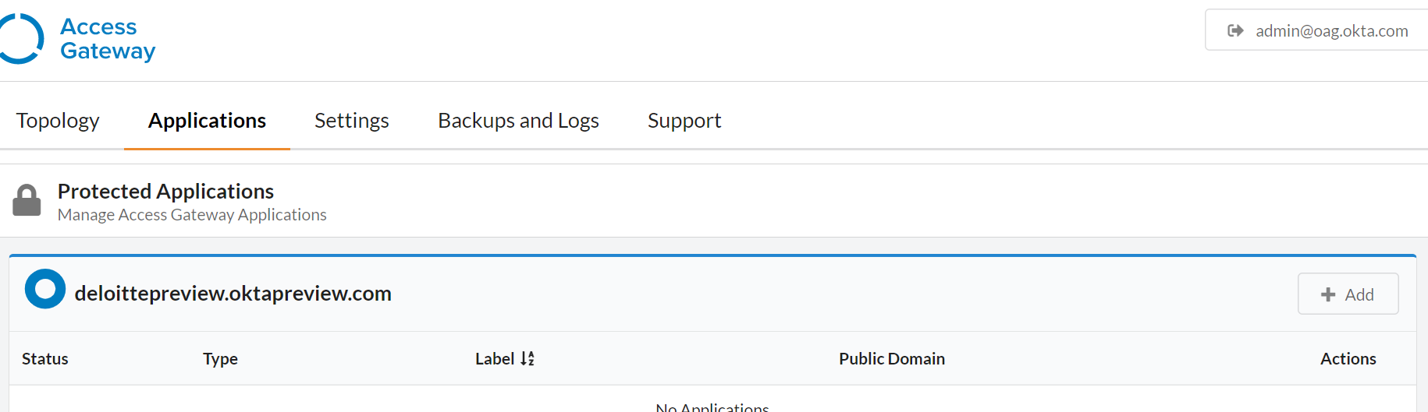

1. From the list of applications, select **Access Gateway AdminUI**.
2. Click **Create**.

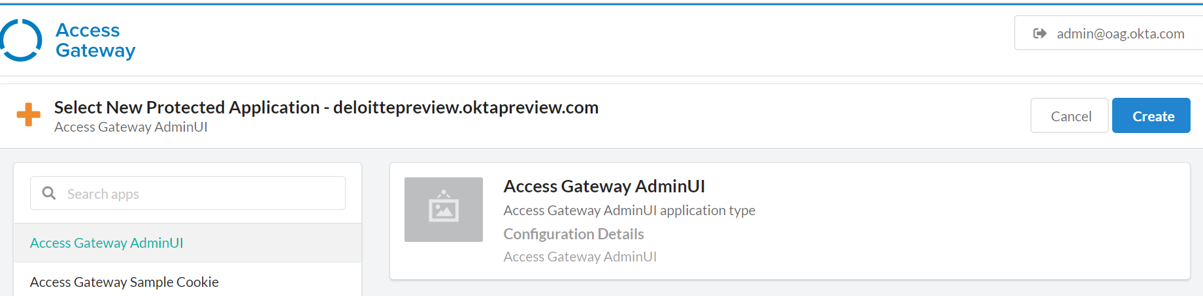

1. In the **Essentials** section, configure the following values.

| **Attribute** | **Value** |
| --- | --- |
| Label | OAG Admin Console |
| Public Domain | gw-admin.<abc>.<yourdomain> |
| Groups | OAG  (group created previously) |
| Description | An appropriate description |

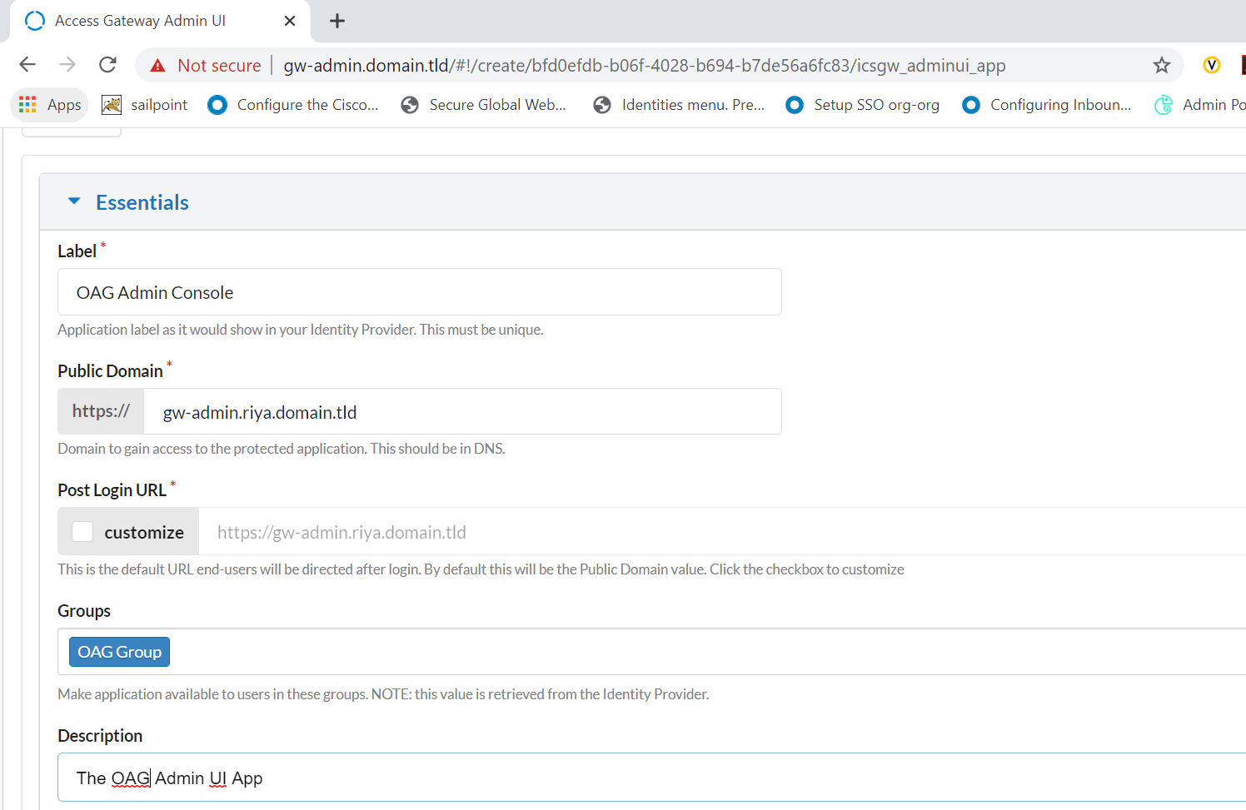

1. Click **Next**. The Attributes tab is displayed.

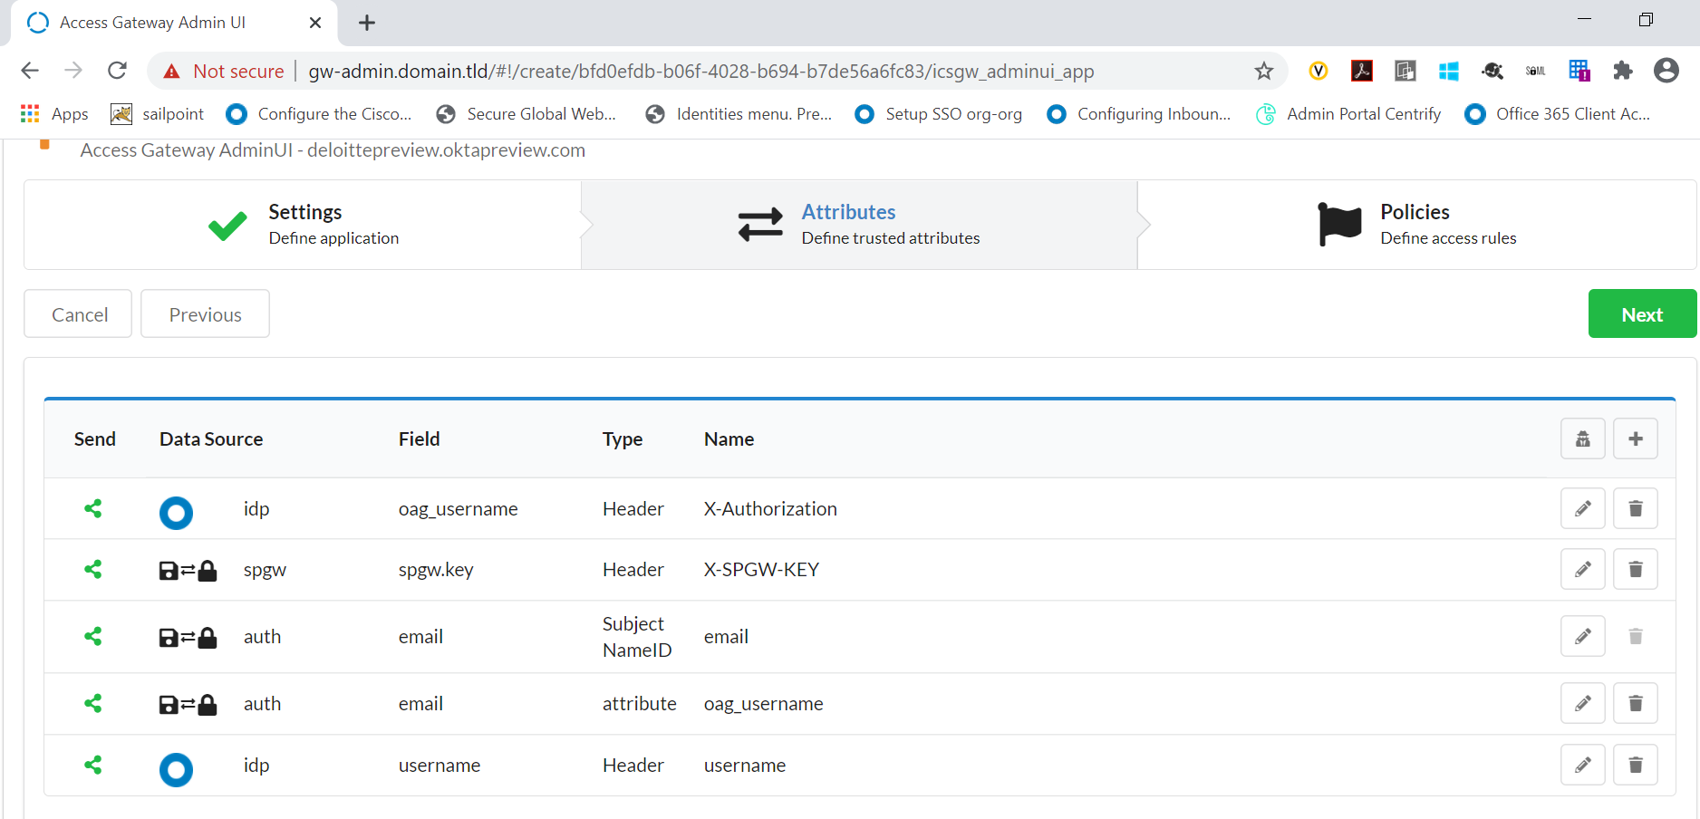

1. Click **Next**. The Policies tab is displayed.

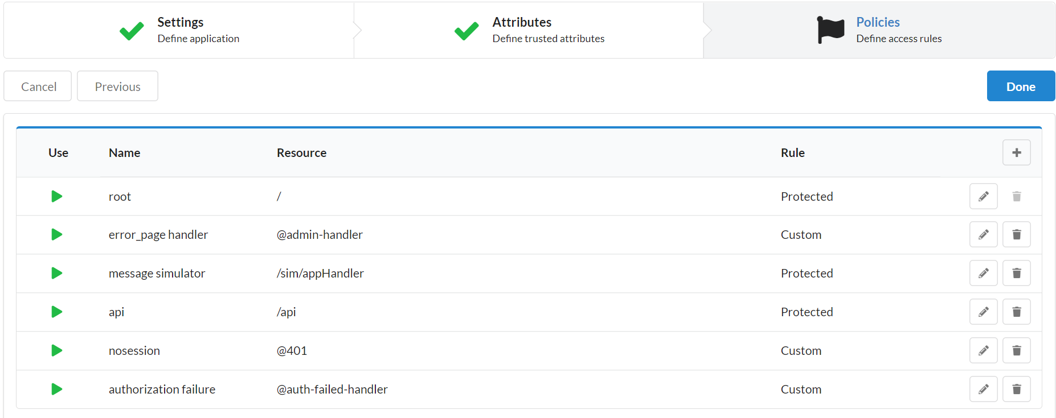

1. Click **Done**.
2. Sign out of the Access Gateway Admin UI console.
3. Sign in to your Okta org as a user in the previously created Access Gateway admin group.
4. You should see a notification has been added to the Access Gateway Admin UI console.

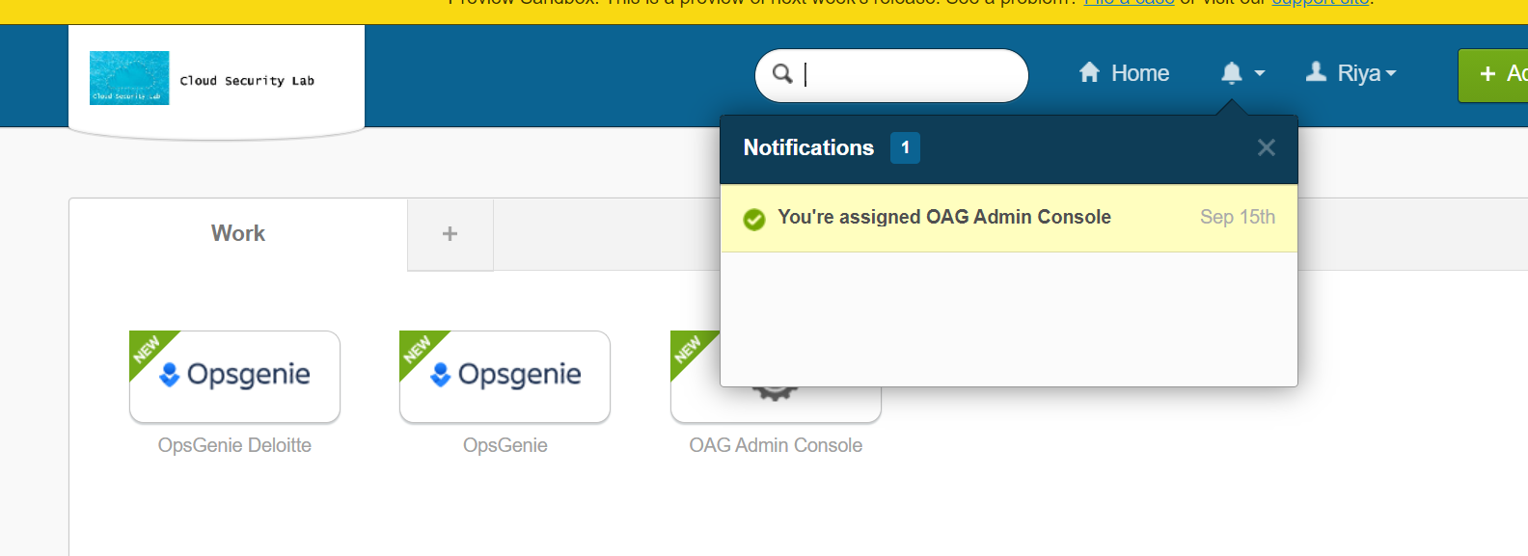

1. Click the application tile and you will be signed in to the Access Gateway Admin UI console as administrator.

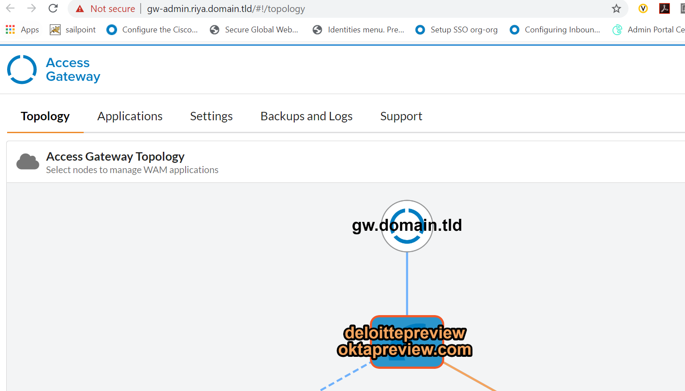

**Create Sample cookie application**

1. Sign in to the Access Gateway Admin UI console.
2. Click the **Applications** tab.
3. Click **+Add** to add a new application.
4. Select the **Access Gateway Sample Cookie** option from the left column menu, and click **Create**.

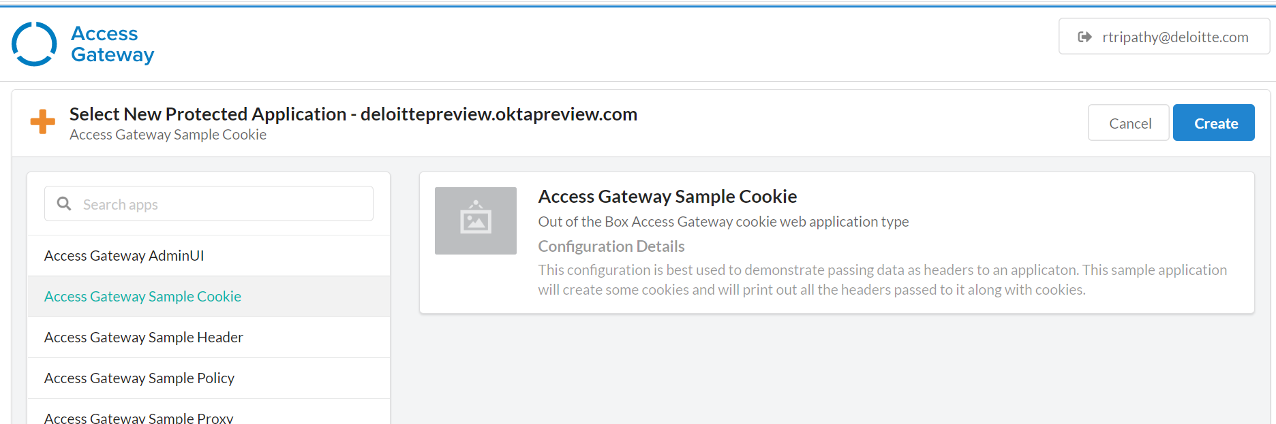

The **New Protected Application** wizard will start and display the **Setting** tab for the application being added.

1. In the **Essentials** pane specify the following:

| **Field** | **Value** |
| --- | --- |
| **Label** | A name for the application. Default is **Sample Cookie App**. |
| **Public Domain** | A fully qualified host name such as cookie.<your domain tld> |
| **Group** | Enter the group containing the users who should have access to the application. |
| **Description** | Optional. An appropriate description for your application. |

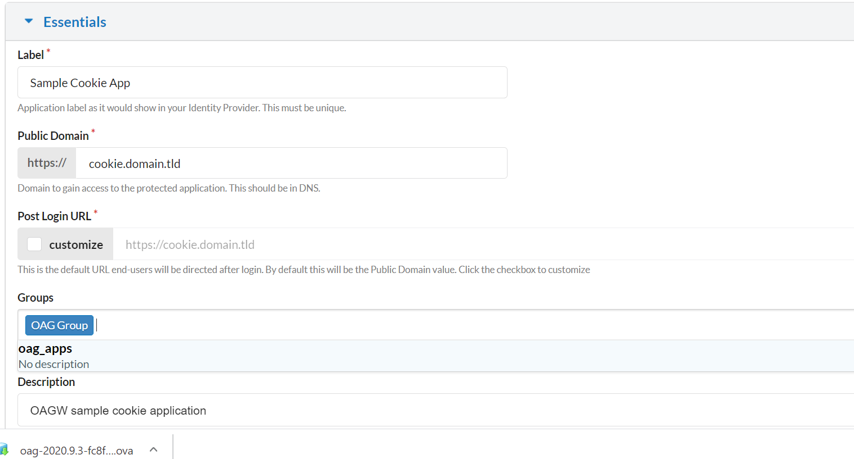

Note: Add the app domain name in the host file

1. Click **Next**. The **Attributes** pane displays.
2. To add additional header attributes, pane, click the **+**.

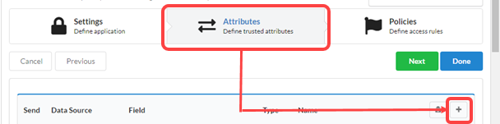

The **Add new Attribute** window opens after the list of existing attributes. Here company attribute has been added.

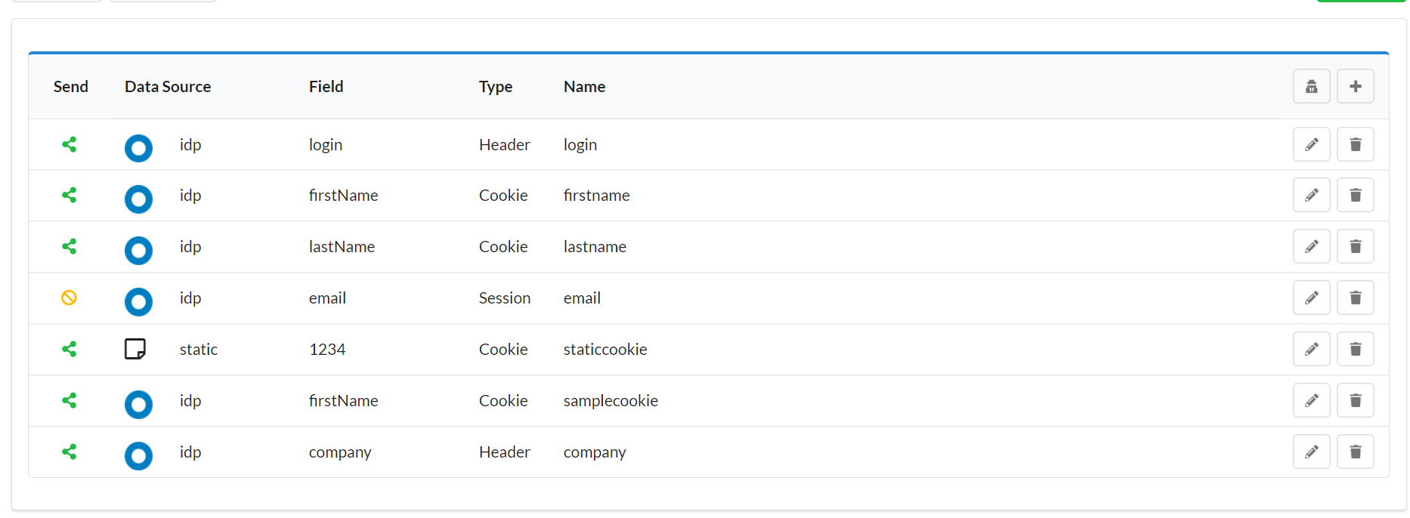

1. Click **Okay** to add the new field. Click **Done**.  
   Access Gateway adds the new application and redirects to the **Applications** tab.

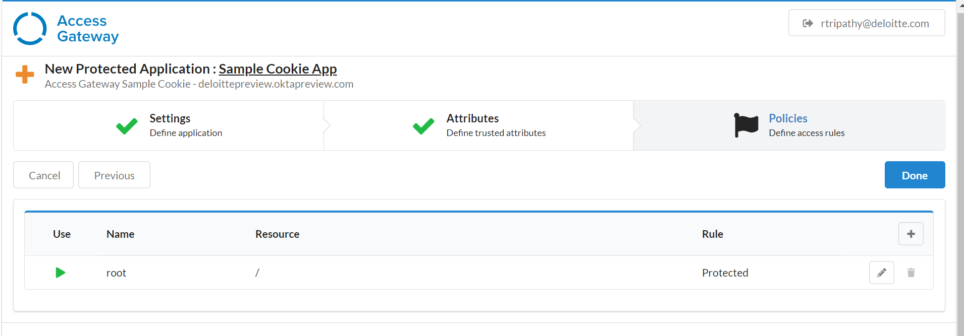

## Test the sample cookie application

1. Click **Goto application** and select **IDP Initiated** to verify the application is working.

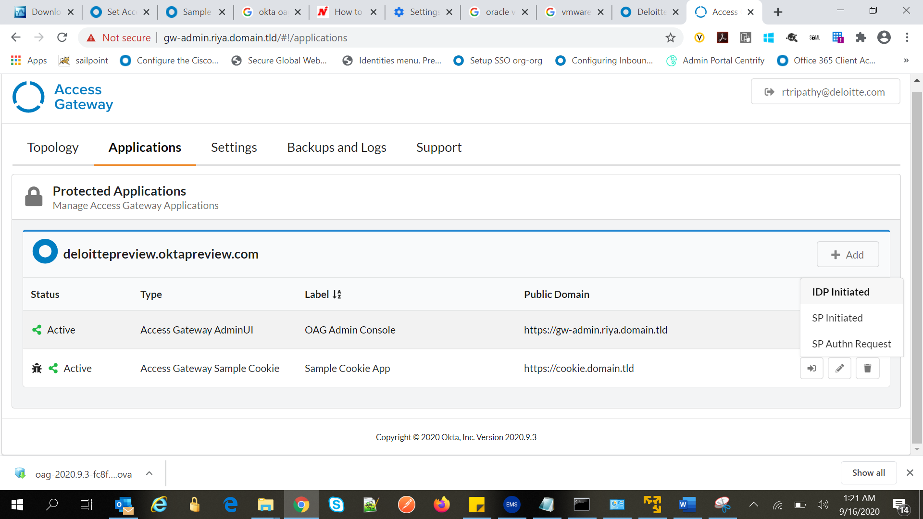

1. In the application page, review and verify that the **Sample Cookie App** sent to Okta matches your profile information.

